**Contents**

Laboratory Rules 1

Writing Up Your Lab Report 2

Marking Scheme 3

2nd Semester Experiments

Experiment 1. Sound Waves 4

Experiment 2. Wheatstone Bridge 8

Experiment 3. Basic Electricity 13

Experiment 4. Grating Spectrometer 18

Experiment 5. Lenses 31

Appendix

Appendix 1. Significant Figures 37

Appendix 2. Graphs 39

Appendix 3. Uncertainties / Errors 41

Appendix 4. Galvanometer 45

## Laboratory Rules

The safety of everyone working in the undergraduate laboratories is of prime importance and your co-operation in this matter is obligatory. Laboratories are potentially dangerous environments but the dangers can be minimized and safety ensured if all working there behave in a mature and responsible manner.

1. Attendance is mandatory. If you cannot attend a laboratory session, you should notify the year course coordinator / Lab Supervisor - if possible in advance, otherwise as quickly as possible afterwards.

2. You are not allowed to leave the laboratory without showing your final results and analysis to your demonstrator. At the end of the session you should leave your bench tidy for the next user. Switch off and disconnect all apparatus.

3. If your partner is absent you have to do the experiment on your own or speak to demonstrator.

4. Stick to assigned timetable.

5. Strictly no eating, drinking, or smoking in the laboratory, but you are allowed to take a brief break during the laboratory session.

* Every student is expected and required to respect the rights of fellow students and the authority of the University academic and other staff in the performance of their duties.
* Every student is expected and required to observe the rules and regulations of the University.
* Every student is expected and required to conduct themselves in a manner conducive to the academic environment of the University and the promotion of its objectives.
* Plagiarism is the representation of another person’s work as one’s own, and includes unacknowledged use of material from books or periodicals, from the internet, from teachers and tutors, or from other students, without full acknowledgement of the sources.

## Writing Up Your Lab Report

**1. Preparation for each Practical Session.**

Read the laboratory manual and consult the recommended texts before coming to the laboratory. Make notes and bring those with you.

**2. Practical Report.**

The following topics should be covered in the report.

* Date, Student number, Name, Title, and Aim.
* Brief overview and context of the experiment and main related theory. (Show you understand what ideas are being tested and how it is done and what you expect to show)
* Tables of Results - the results of your experiments should be recorded in ink immediately they are made. The laboratory manual suggests how the tables of results might be laid out. Give yourself plenty of room in the layout.
* Clarity is very important. If you have cause to re-measure a certain quantity, record this fact below the table of results. Record the ‘experimental uncertainties’ as you enter each item on the table.
* Any relevant graphs should be drawn on the graph paper in the report using pencil.
* Calculations - give the relevant formula and show how you arrived at your answer. Do not hold on to unjustifiable decimal places in your results. Use scientific notation e.g. write 7.43×10-3 instead of 0.00743. Conclusions (not more than 100 words)- Summaries the aim and method of the experiment. State your main results. Comment on how your results compare with the expected values and explain any discrepancies.

**Sample Conclusions: (1. Newton's Second Law)**

A horizontal air track apparatus was used to measure the acceleration of a mass of 450 grams in response to an applied force. The applied force was due to gravity acting on part of the 450 grams. We have found that the acceleration of the mass is indeed proportional to the applied force and that the slope of a graph of force versus acceleration gave a straight line with slope 0.440 kg. This is close to the expected value of 450 grams, and in reasonable agreement with Newton’s Second Law.

## Marking Scheme

All experiments are graded out of 10 (no half marks).

The following is a guide to how marks are awarded. There is flexibility between experiments as not all experiments can be equally assessed e.g. in terms of error analysis.

Marks are given for:

* Presentation of Results.
* Calculations.
* Uncertainty Analysis.
* Methods / Precautions.
* Apparatus / Diagrams.
* Conclusions.
* Questions.

**Guide to marks for Laboratory reports.**

0 - Nothing written in laboratory report.

1 - Bare minimum (e.g. diagram of apparatus); no results, no calculations.

3 - Description plus some results, but nothing else.

4 - Reasonable description and results, but no calculations or discussion (or results are clearly wrong, with no understanding illustrated).

5 - Description, results, brief discussion, but no error analysis (or incorrect errors, and perhaps some mistakes in calculations).

6 - Reasonably complete report, with some error analysis (may not be fully correct).

7 - Good report with correct error analysis and some relevant discussion of results.

8 - As 7 with good discussion - clear indication of full understanding.

9 - Excellent report in most aspects, with one or two reservations.

10 - Excellent report in all aspects.

## Experiment 1. Sound Waves

**1. Aim:**

The determination of the velocity of sound.

**2. Theory:(** **Read: Cutnell and Johnson – Chapter 16.5, 17.6)**

The speed of sound ‘*v*’ in an ideal gas at temperature *T* is given by

(1)

where k is Boltzmann’s constant, m is the mass of a gas molecule and γ is the ratio of specific heat capacity at constant pressure to specific heat capacity at constant volume. *T* is measured in kelvin. Accordingly, the velocity of sound at 0 ℃ or 273.15 K is given by

(2)

Using the equation for an ideal gas *vt* can be written in terms of the gas pressure *P* and

density *ρ*

(3)

The expression ‘*P*’ is the bulk modulus B of the gas so

(4)

**Half-Wavelength or Second Resonance Method.**

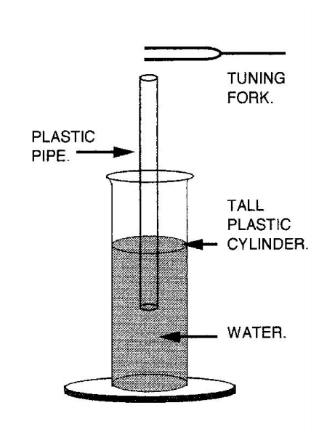 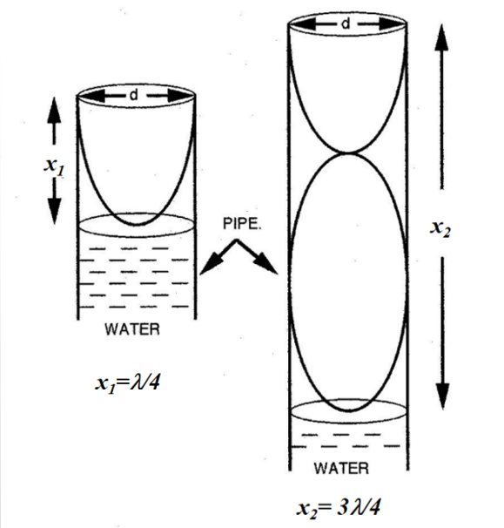

Fig. 1 Schematic diagram.

Set up the apparatus as shown in the Fig.1. The resonance tube is placed well down in the graduated cylinder. Strike the tuning fork on the felted wooden block. Hold the vibrating fork horizontally so that the end of one prong is directly over the end of the tube (see Fig.1). Raise the tube out of the water until the note or sound reaches its highest value (i.e. resonance).

Now if ε is the end correction then

(5)

and

(6)

Therefore

(7)

and since

(8)

then

(9)

**3. Procedure:**

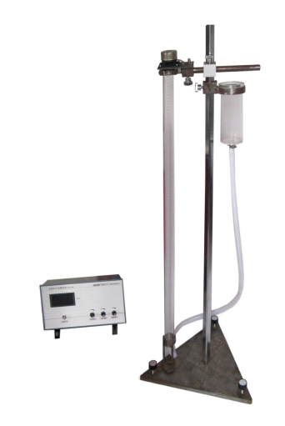

Fig.2 The instrument structure.

(a) The instrument structure as shown in the Fig.2. Turn on the audio signal generator power and adjust the frequency to **500 Hz**. Adjust the output level so that the small horn makes a small sound when it is just audible.

(b) Adjust the height of the water container so that the water surface in the pipe rises to about 5 cm from the pipe tube mouth. Adjust the height of the bucket to make the water surface in the glass tube slowly drop, and listen to the sound of the small horn gradually become stronger. The sound of the trumpet is the strongest, and then the sound will weaken when the water surface drops again.

(c) If the water surface continues to fall, there will be one or two resonances. Roughly record the position of the water surface during resonances and get familiar with it several times.

(d) Lift the water surface to the first resonance position, carefully adjust the water surface, make it gradually close to the place with the largest sound from both sides, and record the reading of the water surface position ***x1*** when the sound is the largest.

(e) To fall the water surface, repeat step (d), and measure the exact position of the water surface ***x2*** during the second resonance.

(f) Change the output frequency of the signal generator to 600 Hz, 700 Hz, 800 Hz, 900Hz, and 1000Hz, and repeat steps (d) and (e) .

Draw the following results table in your report.

|  |  |  |  |  |
| --- | --- | --- | --- | --- |
| ***f***(Hz) | ***T****=1/f* (ms) | ***x1*** (cm) | ***x2*** (cm) | *Δx=****x2-x1*** (cm) |
| 500 |  |  |  |  |
| 600 |  |  |  |  |
| 700 |  |  |  |  |
| 800 |  |  |  |  |
| 900 |  |  |  |  |
| 1000 |  |  |  |  |

(g) Record the temperature *T* of the laboratory, and then calculate velocity of sound at 0℃. An acceptable velocity of sound at 0℃ is 331.5 m/s.

**4. Results:**

Draw a graph of displacement difference *Δ****x*** versus the Vibration period ***T*** of the experiment, i.e. plot *Δ****x***on the *y* axis and ***T*** on the *x* axis. Measure the slope of your graph and calculate velocity of sound.

**5. Error Analysis:**



To calculate , add the errors (i.e. ± 1 mm) on *x1* and *x2*, and put this over (*x2*-*x1*) i.e.



**6. Conclusions:**

In no more than 100 words write a succinct summary of what you have done. State the goal and method of the experiment. State your main results.

## Experiment 2. Wheatstone Bridge

1. **Aim**

To determine an unknown resistance using a Wheatstone bridge.

1. **Theory(Read: Cutnell and Johnson-Chapter 20.1-20.3 and 20.11)**

For measuring accurately any electrical resistance, single bridge, also known as Wheatstone bridge is widely used. A Wheatstone bridge is an electrical circuit used to measure an unknown [electrical resistance](http://en.wikipedia.org/wiki/Electrical_resistance) by balancing two legs of a [bridge circuit](http://en.wikipedia.org/wiki/Bridge_circuit), one leg of which includes the unknown component. In many cases, the significance of measuring the unknown resistance is related to measuring the impact of some physical phenomenon (such as force, temperature, pressure, etc.) which thereby allows the use of Wheatstone bridge in measuring those elements indirectly.

The apparatus used in this experiment is a simple form of the Wheatstone bridge, known as the slide-wire or metre bridge. The circuit below is the electrical equivalent of the slide-wire bridge, as shown in Fig. 1. It consists of four bridge arms, ***Rx*** represents an unknown resistance and ***Rs*** is a decade variable resistance. A metal wire about one metre length is fixed on a wooden base. The slider used to balance the bridge is located at a distance L1 from one end of the wire and L2 from the other, and the corresponding resistance are ***R*1***,* ***R*2**, respectively. In addition, the circuit contains a "Bridge" balance indicator (usually a galvanometer), working power E and slide-wire rheostat.



Fig.1 Principle of Wheatstone bridge circuit

After ***R*1***,* ***R*2** were suitably selected, by adjusting the variable resistor, then the [voltage](http://en.wikipedia.org/wiki/Voltage) between the two midpoints (**B** and **D**) will be zero and no [current](http://en.wikipedia.org/wiki/Current_(electricity)) will flow through the [galvanometer](http://en.wikipedia.org/wiki/Galvanometer). Thus the bridge is in the status of balance. Detecting zero current with a galvanometer can be done to extremely high accuracy. Therefore, if***R*1***,* ***R*2** and ***Rs*** are known to high precision, then ***Rx*** can be measured to high precision. Very small changes in ***Rx*** disrupt the balance and are readily detected.

When the bridge is balanced, that is ***V*BD** =0, thus

,  (1)

So we can get that

 (2)

That is

 (3)

So  (4)

In fact, it is difficult to exactly decide the value of, so we use "exchange measure method" to obtain ***Rx***. Exchange the positions of ***R*1**and ***R*2**, or ***R*s** and ***Rx***, and adjust ***R*s** to a new value******, the bridge can get a new balanced state, thus

 (5)

Combine equation (4) and equation (5), we can get

 (6)

This equation has nothing to do with ***R*1**and ***R*2**. In this way, we can make the error only relate to the instrument error of ***R*s**, which is the instrument error of the resistor box.

1. **Procedure**
2. Connect the circuit as shown in Fig.2, andensure that all connections are tight. Zero the galvanometer and turn it to 1 mA gear. Meanwhile, adjust the slide-wire rheostat to a maximum value in the circuit. Then, set the power supply as 3.00 V.
3. Adjust the variable resistance box ***R*s** (see **gradual approach**) and then press the slider firmly against the wire until the galvanometer reads zero. Note that the slider should press near the centre of the wire (about 50 cm). You can press the left or right side of the slider, and at the position about in the reading scale, see Fig.3. Remember that once the pressed position is determined, it can not be changed throughout the experiment. That means when you adjust ***R*s** and judge whether the galvanometer reads zero, you should press the slider at the same position in the reading scale.

**Gradual approach:** ① Adjust ***Rs*** to a small value ***Rs1***(eg. 0****) and the galvanometer pointer is tilted to one side (see Fig.4a). ② Adjust ***Rs*** to some large value ***Rs2***(eg.100****), the pointer is tilted to the other side (see Fig.4b). When the bridge is balanced, ***Rs*** must between ***Rs1*** and ***Rs2***. ③ Select a new resistance value ***Rs3*** between ***Rs1*** and ***Rs2***, and observe the pointer deflection again. ④ Determine the new resistance range based on the result of pointer deflection after selecting ***Rs3***. ⑤Repeat this procedure until the current through the galvanometer is made zero.

1. Set the galvanometer to 300 μA and 30 μA gear, respectively, then adjust ***R*s** until the current through the galvanometer is made zero.
2. Adjust the slide-wire rheostat to zero value in the circuit, then adjust ***R*s** until the current through the galvanometer is made zero. Record ***Rs***.
3. Exchange the positions of ***Rs***and ***Rx***, repeat procedures (1)-(4), adjust ***R*s** to a new value******, and make the bridge to get a new balanced state, then record****.



Fig.2 Set-up of Wheatstone Bridge apparatus.

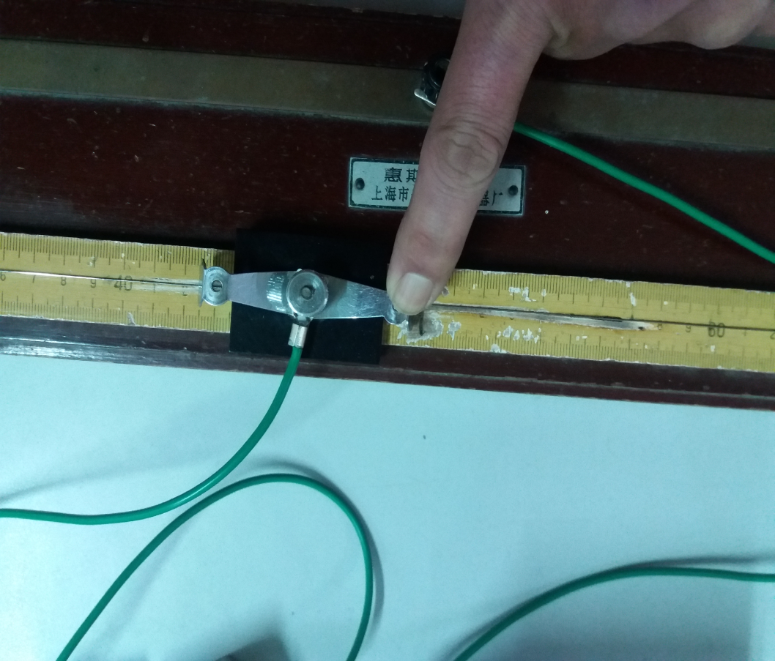

Fig.3 Pressed position of the slider (press the leaf spring against the wire near the center position, about 50 cm in the reading scale, as shown by the red arrow).



Fig.4 Deflection of the galvanometer pointer with different value of *Rs*.

**4. Data, result & error analysis**  Level of the resistance box 

|  |  |  |  |  |  |
| --- | --- | --- | --- | --- | --- |
| **Resistor number** | **Before the exchange ofand** | **After the exchange ofand** |  |  |  |
| **1** |  |  |  |  |  |
| **2** |  |  |  |  |  |

**5. Conclusions**

In no more than 100 words write a succinct summary of what you have done. State the goal and method of the experiment. State your main results, i.e.: What value did you get for the unknown resistor? Is your result in agreement with the accepted value? If your result is not consistent with the accepted value can you suggest why not ?

## Experiment 3. Basic Electricity

**1. Aim:**

To investigate Ohm’s Law and Kirchhoff’s Rules.

**2. Theory: (Read: Cutnell and Johnson – Chapter 20.2 & 20.10)**

Ohm’s Law states that the ratio V/I is constant, where V is the voltage applied across a piece of material (such as a wire) and I is the current through the material:

 or 

R is the resistance of the piece of material and, for metals, it is constant over a wide range of voltages and currents. R is temperature dependent.

Resistors wired in series have an equivalent resistance R=R1+R2+etc. Resistors wired in parallel have an equivalent resistance:



For two resistors in parallel, the equivalent resistance is:



Electric circuits that contain a number of resistors can often be analyzed by combining individual groups of resistors in series and parallel. However, there are many circuits in which no two resistors are in series or in parallel. To deal with such circuits it is necessary to employ methods other than the series–parallel method. One alternative is to take advantage of Kirchhoff’s rules, named after their developer Gustav Kirchhoff (1824–1887).

There are two rules, the junction rule and the loop rule. The junction rule is an application of the law of conservation of electric charge to the electric current in a circuit. Since there is no accumulation of charges at the junction itself, the total charge per second flowing into the junction must equal the total charge per second flowing out of it. In other words, the **junction rule** states that the total current directed into a junction must equal the total current directed out of the junction,

The loop rule is an application of the principle of conservation of energy to the electric potential that exists at various places in a circuit. Let us follow a positive test charge clockwise around the circuit,when the test charge arrives back at its starting point, there is no net change in electric potential energy, the gains matching the losses. The **loop rule** states that for a closed circuit loop the total of all the potential rises equals the total of all the potential drops.

**Kirchhoff’s Rules**

**Junction rule**. The sum of the magnitudes of the currents directed into a junction equals the sum of the magnitudes of the currents directed out of the junction.

**Loop rule.** Around any closed-circuit loop, the sum of the potential drops equals the sum of the potential rises.

**3. Procedure:**

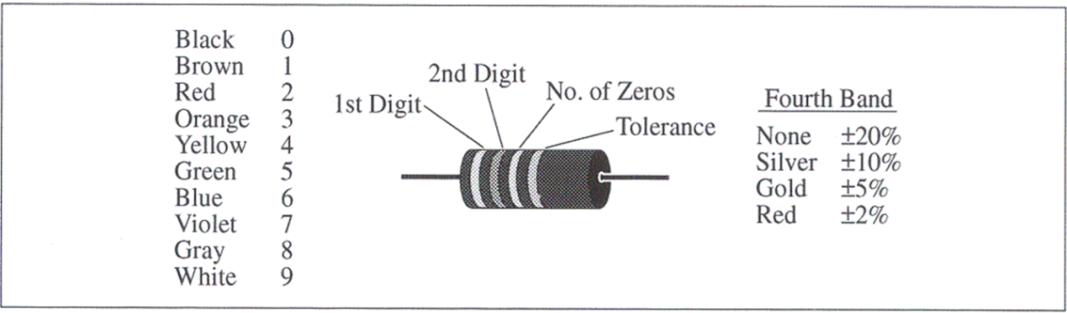

1、The purpose of this section is to investigate the three variables involved in a mathematical relationship known as Ohm’s Law.

Resistors are colour coded:

1. Select three resistors with the same colour markings. Using the multimeter and the above colour code chart, fill out a copy of the table shown below in the lab notebook.

|  |  |  |  |  |  |
| --- | --- | --- | --- | --- | --- |
|  | Colours  1st 2nd 3rd 4th | Coded Resistance | Measured Resistance | %  Error | Coded Tolerance % |
| #1 |  |  |  |  |  |
| #2 |  |  |  |  |  |
| #3 |  |  |  |  |  |

1. Connect the three resistors in a **series** circuit as shown below. Copy the diagram into the lab notebook. Calculate and record the value of R12, R23 and R123 as predicted by Ohm’s Law（use resistance measured before, then measure them by a multimeter and compare their resistance.

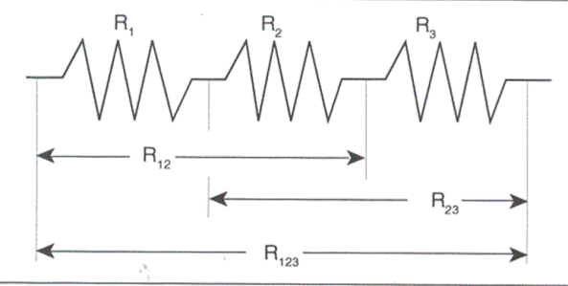

|  |  |  |
| --- | --- | --- |
|  | Predicted by Ohm’s Law  (Ω) | Measured  Resistance  (Ω) |
| R12 |  |  |
| R23 |  |  |
| R123 |  |  |

(c) Connect the three resistors in a **combination** circuit as shown below. Copy the diagram into the lab notebook. Calculate and record the value of R1, R23 and R123 as predicted by Ohm’s Law., then measure them by a multimeter and compare their resistance.

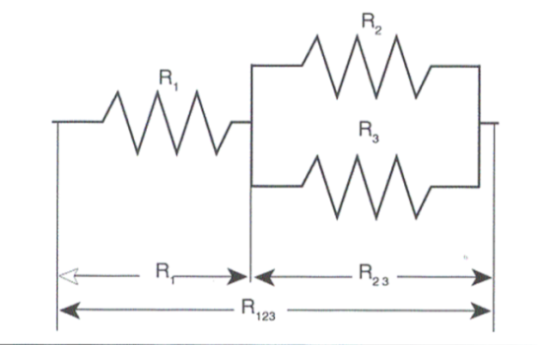

|  |  |  |
| --- | --- | --- |
|  | Predicted by Ohm’s Law (Ω) | Measured resistance(Ω) |
| R1 |  |  |
| R23 |  |  |
| R123 |  |  |

(d) Design and construct a parallel circuit using the same three resistors. Draw a circuit diagram in the lab notebook and record the theoretical and actual equivalent resistance of the parallel arrangement.

|  |  |  |
| --- | --- | --- |
| Three Resistors in Parallel | Predicted by Ohm’s Law (Ω) | Measured resistance (Ω) |
| R123 = |  |  |

(e) Select a resistor, use an ammeter to measure the current passes through it, and use a voltmeter to measure the volt on the resistor simultaneous.

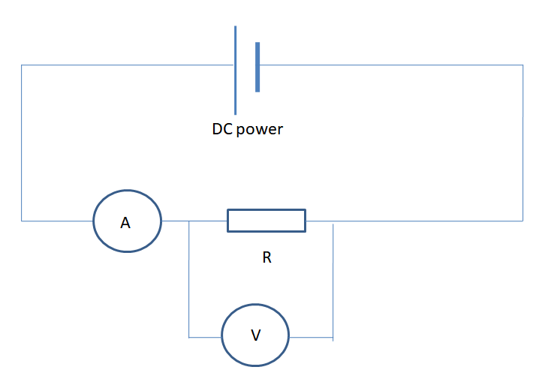

Change the output voltage of the DC power，record voltage and current,then draw a graph of voltage versus current,the slope of line is resistance. Compare the result with the resistance measure by Ohmmeter.

|  |  |  |  |  |
| --- | --- | --- | --- | --- |
| Output voltage (V) |  |  |  |  |
| Voltage of resistor (V) |  |  |  |  |
| Current (mA) |  |  |  |  |

**2、**Invest the Kirchhoff’s Rules

Connect a circuit as shown below, set the DC power to 5 volts, record I1、I2、I3、U1、U2、U3、U4 and U5, then change the DC power to 10 volts, record the currents and voltages, fill the tablets below.

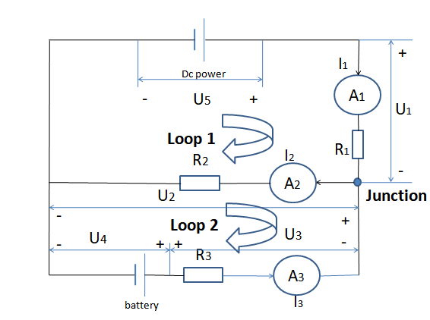

**Tablet: Junction rule**

|  |  |  |  |  |  |
| --- | --- | --- | --- | --- | --- |
| **Dc power**  **(V)** | **I1**  **(mA)** | **I2**  **(mA)** | **I3**  **(mA)** | **Sum of the current Into the junction (mA)** | **Sum of the current out of the junction (mA)** |
| **5** |  |  |  |  |  |
| **10** |  |  |  |  |  |

**Tablet: Loop rule**

|  |  |  |  |  |  |  |  |  |
| --- | --- | --- | --- | --- | --- | --- | --- | --- |
| **Dc**  **(V)** | **U1**  **(V)** | **U 2**  **(V)** | **U 3**  **(V)** | **U 4**  **(V)** | **U 5**  **(V)** | Loop | sum of the potential drops  **(V)** | sum of the potential rises  **(V)** |
| **5** |  |  |  |  |  | **1** |  |  |
| **2** |  |  |
| **10** |  |  |  |  |  | **1** |  |  |
| **2** |  |  |

**4. Conclusions:**

Summarise the most important elements of the experiment and state your main conclusions.

## Experiment 4. Grating Spectrometer

**1. Aim:**

Measurement of the wavelengths of light from a mercury lamp using a grating spectrometer.

**2. Theory: (** **Read: Cutnell and Johnson – Chapter 27.7)**

A spectrometer consists of a collimator that produces a parallel beam of light from a lamp, a diffraction grating on a turntable that disperses the light and a telescope to view the light, as shown in **Fig. 1**.

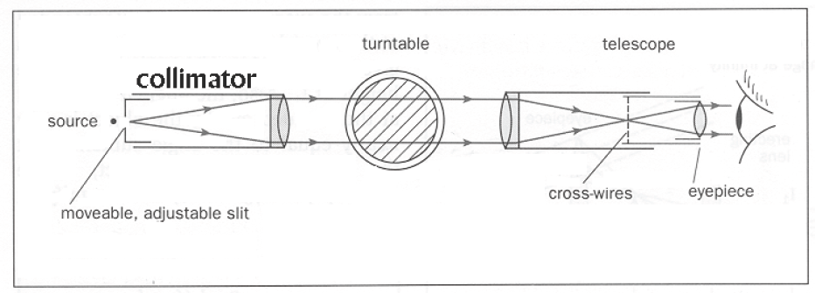

**Fig. 1.** Structure of a spectrometer.

A diffraction grating will separate light into its constituent colours. A diffraction grating consists of alternate opaque and transparent lines. Dispersion occurs because constructive interference occurs for light deflected in certain specific directions. Otherwise destructive interference occurs.

**The physics of a diffraction grating.** Diffraction patterns of bright and dark fringes occur when monochromatic light passes through a single or double slit. Fringe patterns also result when light passes through more than two slits, and an arrangement consisting of a large number of parallel, closely spaced slits called ***a diffraction grating*** has proved very useful. Gratings with as many as 40 000 slits per centimeter can be made, depending on the production method. In one method a diamond-tipped cutting tool is used to inscribe closely spaced parallel lines on a glass plate, the spaces between the lines serving as the slits. In fact, the number of slits per centimeter is often quoted as the number of lines per centimeter.

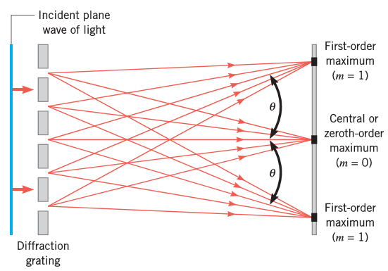

**Fig. 2.** When light passes through a diffraction grating, a central bright fringe (m = 0) and higher-order bright fringes (m = 1,2,...) form when the light falls on a distant viewing screen.

**Fig. 2** illustrates how light travels to a distant viewing screen from each of five slits in a grating and forms the central bright fringe and the first-order bright fringes on either side. Higher-order bright fringes are also formed but are not shown in the drawing. Each bright fringe is located by an angle *θ* relative to the central fringe. These bright fringes are sometimes called the *principal fringes* or *principal maxima*, since they are places where the light intensity is a maximum. The term "principal" distinguishes them from other, much less bright, fringes that are referred to as *secondary fringes or secondary maxima*.

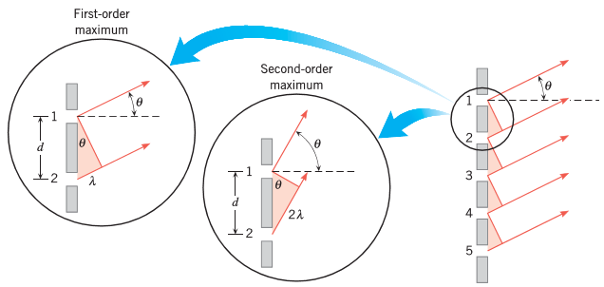

**Fig. 3.** The conditions shown here lead to the first- and second-order intensity maxima in the diffraction pattern produced by the diffraction grating on the right.

Constructive interference creates the principal fringes. To show how, we assume the screen is far from the grating, so that the rays remain nearly parallel while the light travels toward the screen. In reaching the place on the screen where a first-order maximum is located, light from slit 2 travels a distance of one wavelength farther than light from slit 1, as in **Fig. 3**. Similarly, light from slit 3 travels one wavelength farther than light from slit 2, and so forth, as emphasized by the four colored right triangles on the right-hand side of the drawing. For the first-order maximum, the blow-up view of slits 1 and 2 shows that constructive interference occurs when sin *θ* =λ/*d*, where *d* is the separation between slits. A second-order maximum forms when the extra distance traveled by light from adjacent slits is two wavelengths, so that sin *θ* = 2λ/*d*. The general result, of principal maxima of a diffraction grating, is

$\sin{θ}=m\frac{λ}{d}$ m = 0,1,2,3,... (1)

The separation *d* between the slits can be calculated from the number of slits per centimeter of grating; for instance, a grating with 2500 slits per centimeter has a slit separation of *d* = (1/2500) cm = 4.0×10-4 cm. Between the principal maxima of a diffraction grating there are secondary maxima with much smaller intensities. For a large number of slits, these secondary maxima are very small.

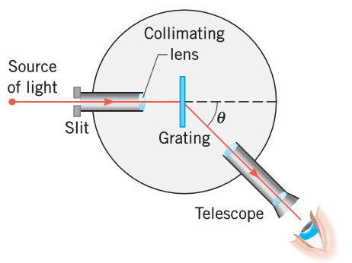

**Fig. 4.** A grating spectroscope.

The physics of a grating spectroscope. An instrument designed to measure the angles at which the principal maxima of a grating occur is called a grating spectroscope. With a measured value of the angle, calculations can be turned around to provide the corresponding value of the wavelength. The atoms in a hot gas emit discrete wavelengths, and determining the values of these wavelengths is one important technique used to identify the atoms. **Fig. 4** shows the principle of a grating spectroscope. The slit that admits light from the source (e.g.. a hot gas) is located at the focal point of the collimating lens, so the light rays striking the grating are parallel. The telescope is used to detect the bright fringes and, hence, to measure the angle *θ*.

In a mercury lamp, mercury vapour is heated to a high temperature, and light is emitted that is characteristic of the atomic structure of mercury. This is like an atomic fingerprint. The spectrum of mercury consists of a number of bright lines, four of which are easily visible using a simple spectrometer and the naked eye. There are two violet /purple lines, one green line and one orange line. The line that is brightest is called the resonance line. In mercury this is the green line.

**3. Procedure:**

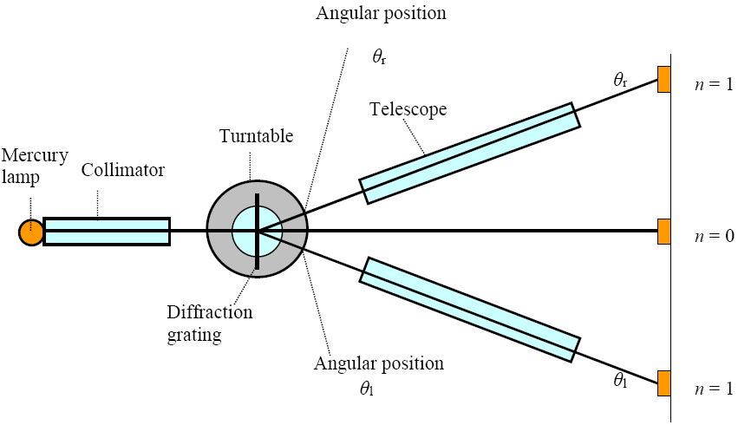

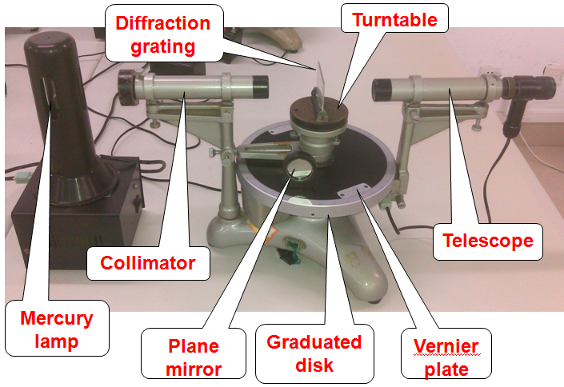

**Fig.5.** Experiment instruments.

(a) Take eye-measurement to adjust the related screws of telescope and turntable, as shown in **Fig. 5**, which makes the telescope and turntable respectively become horizontal to the best of your ability (Important).

For example, as shown in **Fig. 6**, Take eye-measurement to adjust the screws "b" and "c" to the same height to the best of your ability, and adjust the height screw making the telescope become parallel to the line linked by "b" and "c" to the best of your ability.

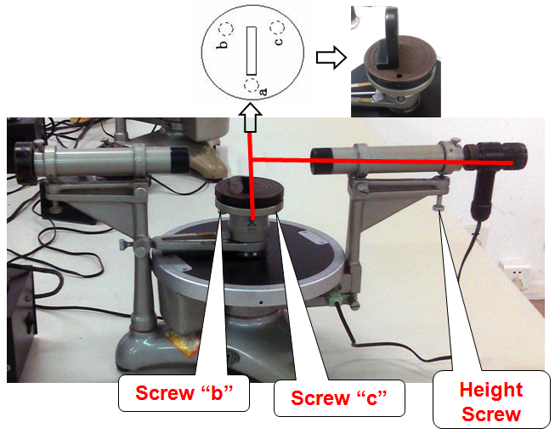

**Fig. 6.** Eye-measurement.

(b) **Telescope:** adjust the telescope to focus on infinity.

b1. Put one eye on the eyepiece to clearly see the black reticle and its cross-wire. If the reticle and its cross-wire is indistinct, rotate the eyepiece, and pull the eyepiece back and forth along the telescope channel, until the reticle and its cross-wire are both clearly seen, as shown in **Fig. 7.**

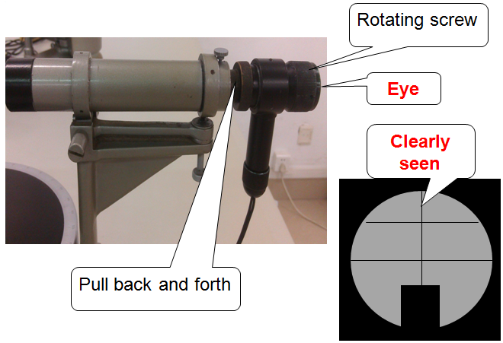

**Fig. 7.** Adjustment of the eyepiece.

b2. Plug in the switch of spectrometer power supply. A green cross-wire appears in the reticle bottom of eyepiece, further adjust the eyepiece to make the green cross-wire clearly seen, as shown in **Fig. 8**.

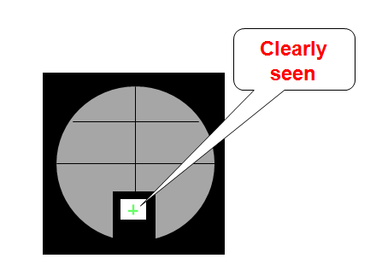

**Fig. 8.** The green cross-wire.

b3. Put the double-faced plane mirror on the turntable, and the plane mirror should be perpendicular to the line linked by the previous two screws with the same height, for example, perpendicular to the line linked by the previous screws "b" and "c", as shown in **Fig. 9.**

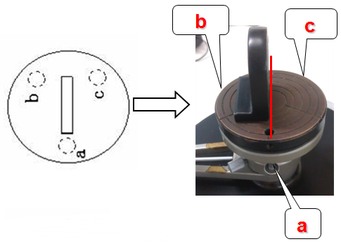

**Fig. 9.** The double-faced plane mirror on the turntable.

Note that the screw connected between the turntable and vernier plate should be locked now, as shown in **Fig. 10.**

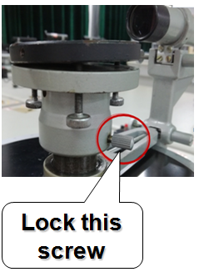

**Fig. 10.** The screw between the turntable and vernier plate.

Slowly turn the vernier plate, and make the plane mirror face the telescope. Carefully find one green cross-wire reflected by the plane mirror inside the eyepiece, as shown in **Fig. 11.** Note that if the green cross-wire reflected by the plane mirror cannot be found, return to the step (a). Repeat until find this green cross-wire.

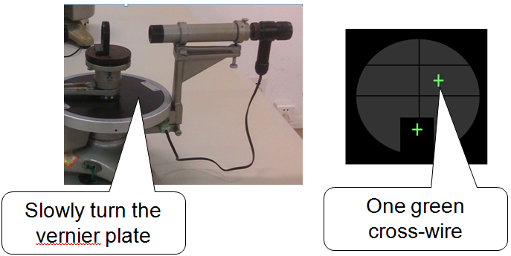

**Fig. 11.** Slowly turn the vernier plate.

b4. After finding this green cross-wire, this cross-wire is generally not just at the focal plane of objective lens and not clear. Again, slowly rotate the eyepiece, and pull the eyepiece back and forth along the telescope channel, until this cross-wire is clear enough, and should be no parallax between the reflected green cross-wire and the green cross-wire in the reticle bottom.

(c) Adjust the optical axis of telescope to be perpendicular to the spin axis of spectrometer.

c1. Rotate the vernier plate by 180 degrees, when the other side of the plane mirror faces the telescope, the green cross-wire can also be seen from the telescope. If when one side of the plane mirror faces the telescope, the green cross-wire cannot be seen, return to the step (a). Repeat until when any one side of the plane mirror faces the telescope, the green cross-wire can be seen from the telescope, as shown in **Fig. 12.**

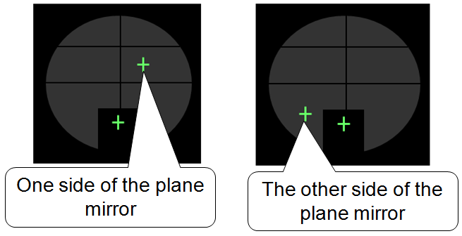

**Fig. 12.** Two sides of the plane mirror face the telescope, respectively.

c2. Slowly adjust related screws to move green cross-wires reflected from both sides of the plane mirror, to simultaneously coincide with the upper black cross-wire of reticle, as shown in **Fig. 13.** This adjustment is generally based on the both-half adjusting method.

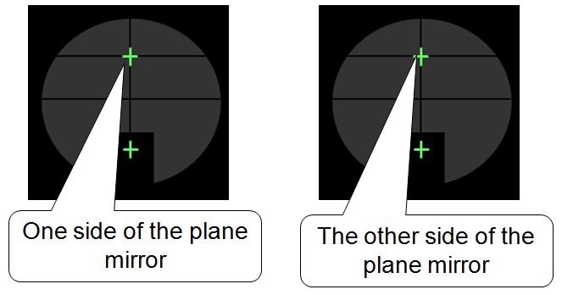

**Fig. 13.** Two green cross-wires in the right positions, respectively.

Until now, all the adjustment of the telescope are finished and the telescope cannot be adjusted any longer, except left and right rotation of the telescope.

The telescope cannot be adjusted since then, except turning it right and left for observations of the whole visual field.

(d) **Collimator:** adjust the collimator based on the telescope that has been adjusted.

d1. Adjust the collimator to generate the parallel light. Take away the plane mirror, turn on the light source of mercury lamp in front of the collimator's slit, and rotate the telescope to face the collimator, as shown in **Fig. 14.**

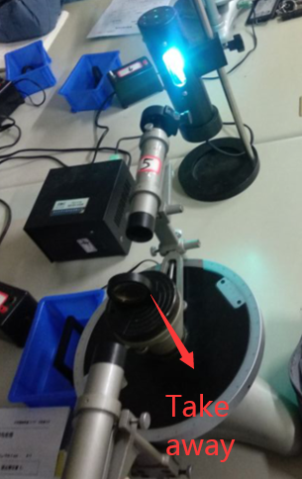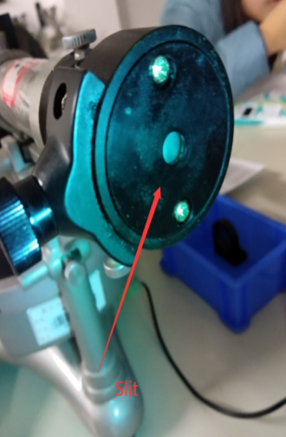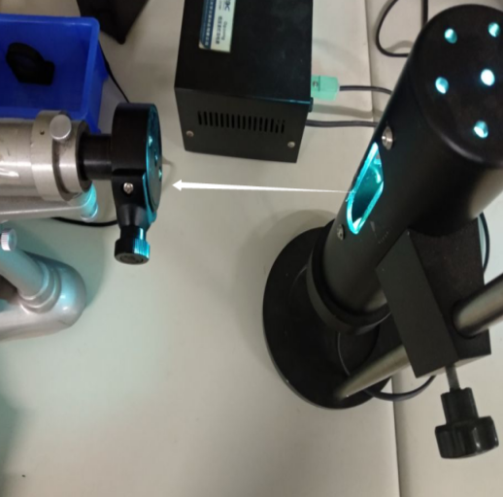

Slit

Take away

**Fig. 14.** The light source of mercury lamp in front of the collimator's slit.

d2. Adjust the position of slit inside collimator. Firstly, loosen the locked screw of slit sleeve above the collimator. Then, pull this slit sleeve back and forth along the collimator channel, until the clear image of slit is seen from the telescope and this image has no aberration with the cross-wire, as shown in **Fig. 15.**

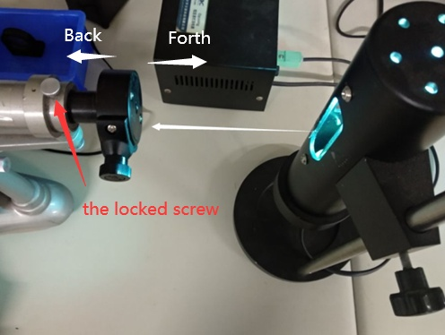 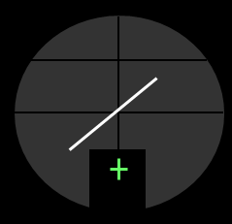

the locked screw

**Fig. 15.** The locked screw of slit sleeve (left) and the image of slit (right).

d3. Adjust the leveling screw under collimator, so that its optical axis is perpendicular to the rotating shaft of spectrometer. Adjust the leveling screw under collimator and rotate the slit sleeve, until the height of slit image is divided equally by the middle horizontal line of reticle, as shown in **Fig. 16.**

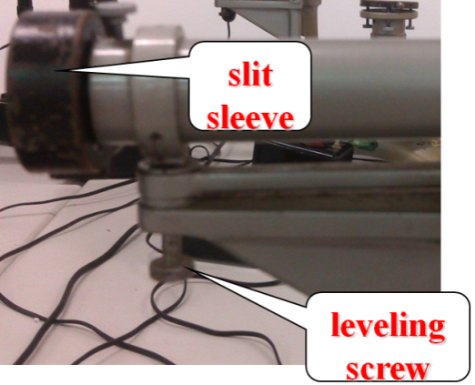 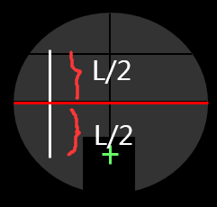

**Fig. 16.** The leveling screw and the slit sleeve (left), and the image of slit (right).

d4. Adjust the width-variation screw outside slit sleeve, until the width of slit image is about 1mm seen from the telescope, then lock the loosen the locked screw of slit sleeve above the collimator to keep this state of slit image, as shown in **Fig. 17.**

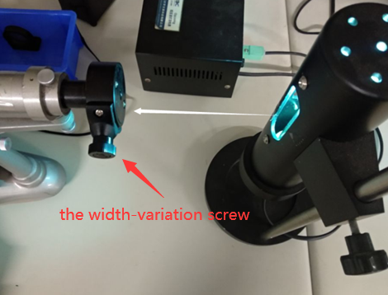 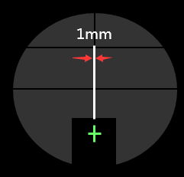

the width-variation screw

**Fig. 17.** The width-variation screw (left) and the image of slit (right).

The collimator cannot be adjusted since then.

(e) **Optical grating:** adjust the optical grating based on the telescope that has been adjusted.

e1. Make the plane of grating to become perpendicular to the axis of collimator. Put the grating on the turntable, and the grating should be perpendicular to the line linked by the previous two screws with the same height, i.e., the previous screws "b" and "c" in the b3 setup, as shown in **Fig. 18.**

Note that the turntable should have a reasonable position to its bottom surface, i.e., neither too high nor too low.

grating

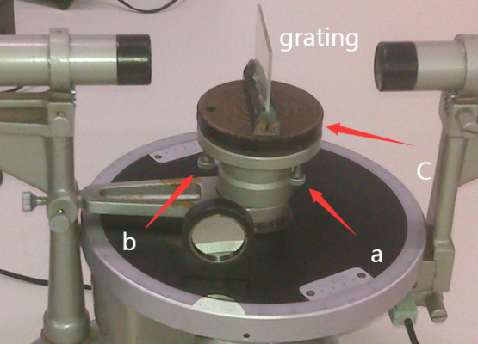

**Fig. 18.** The grating on the turntable.

e2. Turn the vernier plate until the grating faces the telescope. Then slowly adjust the screw "b" or "c", until see the green cross-wire reflected by one of grating planes from the telescope and this green cross-wire coincides with the upper black cross-wire of reticle, as shown in **Fig. 19.**

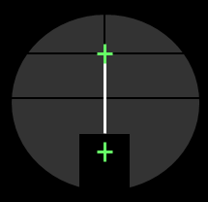

**Fig. 19.** The green cross-wire reflected by one of grating planes.

Lock the tighten screw connected between the vernier plate and collimator, as shown in **Fig. 20**, so that the vernier plate is fixed. Note that the telescope has been turn up and its height screw should not be adjusted any more here.

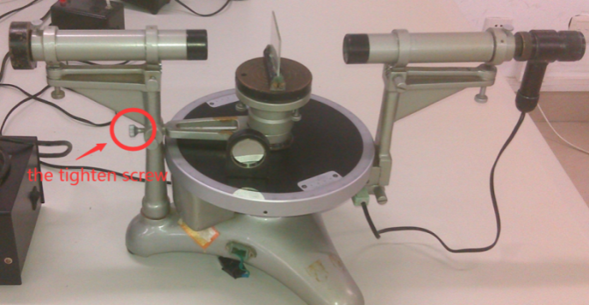

the tighten screw

**Fig. 20.** The tighten screw.

e3. Make the slit of grating to become parallel to the spin axis of spectrometer. Lock the tighten screw of telescope, as shown in **Fig. 21.**

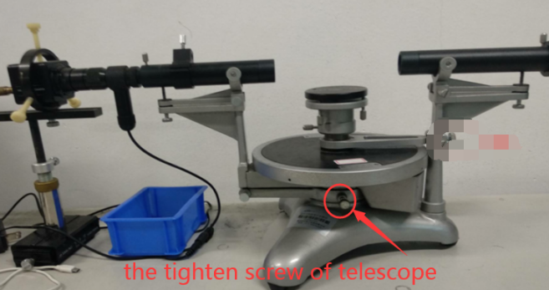

the tighten screw of telescope

**Fig. 21.** The tighten screw of telescope.

Then turn the telescope left and right, and see spectral lines. Note that observe whether each spectral line is equally divided by the middle horizontal line of reticle or not. If not, adjust the screw "a" of the e1 setup until each spectral line is equally divided by the middle horizontal line of reticle, as shown in **Fig. 22.**

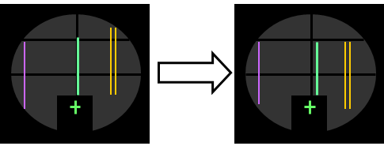

**Fig. 22.** Each spectral line is equally divided by the middle horizontal line of reticle.

e4. Turn the telescope to face the grating, and check whether the plane of grating keep still perpendicular to the optical axis of telescope or not, i.e., to see whether the green cross-wire reflected by one of grating planes coincides with the upper black cross-wire of reticle or not. If not, repeat the e2 and e3 setups many times, until these two conditions, that the green cross-wire reflected by one of grating planes coincides with the upper black cross-wire of reticle and each spectral line is equally divided by the middle horizontal line of reticle, are both satisfied at the same time, as the final result shown in **Fig. 23.** Lock the tighten screw of telescope as shown in **Fig. 21**.

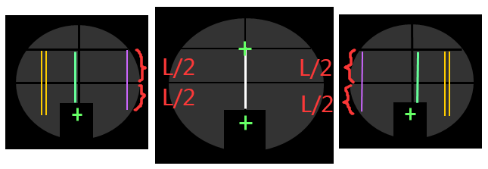

**Fig. 23.** The final result.

(f) **Measurement:** Move the telescope to the left, until the middle vertical line of reticle aims at the first-order (k=1) green spectral line, as shown in **Fig. 24.** Take the reading $α_{1}$ and $β_{1}$ from the scale on the graduated disk and vernier plate, and record your results in a suitable table (see below).

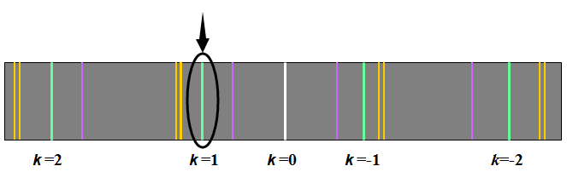

**Fig. 24.** Position of the first-order green spectral line.

Move the telescope to the right, until the middle vertical line of reticle aims at the negative first-order (k=-1) green spectral line, as shown in **Fig. 25.** Take the reading $α_{2}$ and $β_{2}$ from the scale on the graduated disk and vernier plate, and record your results in a suitable table (see below).

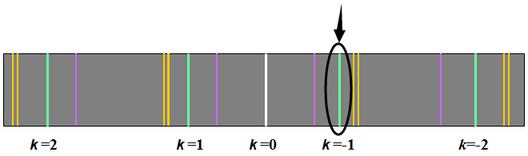

**Fig. 25.** Position of the first-order green spectral line.

Draw the following results table in your report.

Results Table: Measurement of the diffraction angle

|  |  |  |  |
| --- | --- | --- | --- |
| The position T1 of telescope | | The position T2 of telescope | |
|  |  |  |  |
|  |  |  |  |
|  | |  | |

**4. Results:**

(a) Calculate the distance *d* between the slits using $d=\frac{1}{N}$ where N=300 is the number of lines per millimeter on the grating.

(b) Calculate the wavelength $λ$ using $kλ=d\sin{φ}$.

(c) Calculate the percentage deviation B using $B=\frac{λ-λ_{0}}{λ_{0}}×100\%$.

**5. Error Analysis:**

(a) *d* and k can be regarded as two constants.

(b) The uncertainty $∆λ$ of $λ$ is related to the uncertainty $∆φ$ of instrument, using

$∆λ=\frac{d}{k}∙\cos{φ}∙∆φ$,

where $∆φ=1^{'}=0.0003rad$.

**6. Conclusions:**

In no more than 100 words summarise the most important elements of the experiment and state your main results and conclusions. State the goal and method of the experiment. State your main results, i.e.: What value did you get for the experimental wavelength based on the grating spectrometer? Is your result in agreement with the theoretical wavelength? If your result is not consistent with the theoretical wavelength can you suggest why not?

## Experiment 5. Lenses

**1. Aim:**

The determination of the focal length of a convex and a concave lens.

**2. Theory:(** **Read: Cutnell and Johnson – Chapter 26.6 to 26.8)**

(a) The thin-lens equation for convex (converging) and concave (diverging) lenses is



where ‘ *d*0 ’ is the object distance (from the centre of the lens), ‘ *di* ’ is the image distance and ‘ *f* ’ is the focal length. When using the thin-lens equation, it is necessary to follow the appropriate sign convention.

**Summary of Sign Conventions for Lenses**

***Focal length***

‘ *f* ’ is + for a converging lens.

‘ *f* ’ is - for a diverging lens.

***Object distance***

‘ *d*0 ’ is + if the object is to the left of the lens (real object), as is usual.

‘ *d*0 ’ is - if the object is to the right of the lens (virtual object).*

***Image distance***

‘ *di* ’ is + for an image (real) formed to the right of the lens by a real object.

‘ *di* ’ is - for an image (virtual) formed to the left of the lens by a real object.

*This situation arises in systems containing more than one lens, where the image formed by the first lens becomes the object for the second lens. In such a case, the object of the second lens may lie to the right of that lens, in which event ‘ d0 ’ is assigned a negative value and the object is called a virtual object.

(b) If a convex lens is placed between a fixed object and screen, where the distance ‘*D*’ between the object and screen is greater than four focal lengths, then there are two positions of the lens which give a clear image on the screen. If these two positions are a distance ‘d’ apart, it can be shown that the focal length ‘ *f* ’of the lens is given by:



**3. Procedure:**

**(a) *Convex Lens***

The first part of this practical deals with various methods for measuring the focal length of a convex (converging) lens.

**The Plane Mirror Method:**

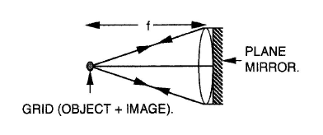

Set up the optical bench as shown overleaf. The screen is not used in this method. Place a plane mirror directly behind the lens (i.e. on the screen side) with the mirrored surface towards the light source. Move the lens holder and plane mirror away from the light source until an image of the grid is seen on the outer black ring around the bulb holder. [The lens holder must be tilted slightly to find the image.] Adjust the lens position until the object (grid) and image are the same size. Measure the distance from the grid to the centre of the lens - this is the focal length.

|  |  |  |
| --- | --- | --- |
| **1-Table of Results - The Plane Mirror Method (convex lens)** | | |
| Position of the object | Position of the convex lens | Focal length(m ± ?) |
|  |  |  |

**The Lens Formula Method:**

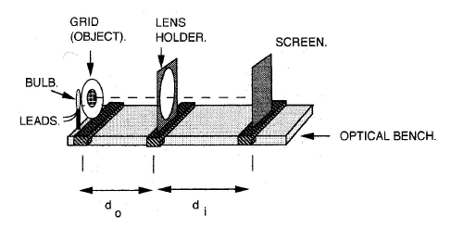

Place the lens holder so that the light source is beyond the focal length - locate the image position by moving the screen until the grid is sharply focused on it. Obtain a series of values of image distance ‘*di*’ and object distance ‘*d0*’. Plot 1/*d0* versus 1/*di* and draw a straight line through the points. Locate the best fit that results in the intercepts of the x-axis and y-axis being the same.

|  |  |  |  |  |  |  |
| --- | --- | --- | --- | --- | --- | --- |
| **2-Table of Results - The Lens Formula Method (convex lens)** | | | | | | |
| Position of the object | Position of the convex lens | Position of the screen | *d0* (cm ± ?) | *di* (cm ± ?) | 1/*d0* (cm-1) | 1/*di* (cm-1) |
|  |  |  |  |  |  |  |
|  |  |  |  |  |  |  |
|  |  |  |  |  |  |  |
|  |  |  |  |  |  |  |
|  |  |  |  |  |  |  |

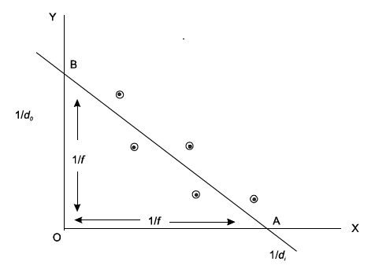

**Calculate** ‘*f*’ from: OA = OB = 1/*f*

In above graph, where ‘*f* ’ is the focal length, the graph may be plotted in cm-1 or any convenient unit but the final result should be quoted in metres.

**The Displacement Method:**

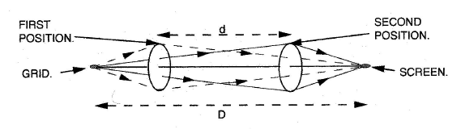

Set up the optical bench so that the light source and screen are more than four times the focal length apart. Move the lens holder until a sharp image of the grid is seen on the screen - mark this position on the bench with a pencil. Slide the lens holder to a second lens position which results in a clear image. Record the distance ‘*d*’ between these two positions and also the distance ‘*D*’ between the grid and the screen. Repeat the measurements at least three times until consistent readings are obtained. In first position the image is magnified, in the second, the image is reduced in size.

|  |  |  |  |  |  |
| --- | --- | --- | --- | --- | --- |
| **3-Table of Results - The Displacement Method (convex lens)** | | | | | |
| Position of the object | Position of the screen | *D* (cm ± ?) | First position of the convex lens | Second position of the convex lens | *d* (cm ± ?) |
|  |  |  |  |  |  |
|  |  |  |  |  |  |
|  |  |  |  |  |  |

**Calculate** ‘*f* ’ from the formula: 

Quote the final result in metres.

**Important information:**

Before the convex lens experiment, we must adjust the optical system coaxial. Using the displacement method can achieve the purpose of rapid adjustment. With the method of ‘large image chasing small image’, the center of the enlarged image and the reduced image formed by the displacement method are superimposed on the screen to achieve the coaxial effect. So, we have to always adjust the holder of the convex lens at the magnification position.

**(b) *Concave Lens***

The second part of this practical sets out to measure the focal length of a concave (diverging) lens.

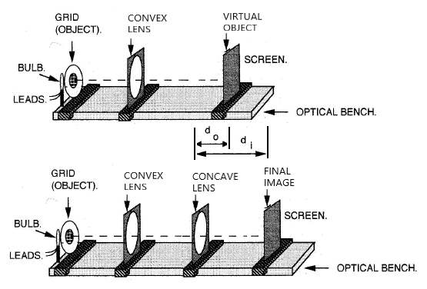

Place the convex and concave lens in one optical system, where the image formed by the first convex lens becomes the object for the second concave lens. In such a case, the object of the second concave lens lie to the right of that concave lens, in which event ‘*d0* ’ is assigned a negative value and the object is called a virtual object.

|  |  |  |  |  |
| --- | --- | --- | --- | --- |
| **4-Table of Results - The Lens Formula Method (concave lens)** | | | | |
| Position of the virtual object | Position of the concave lens | Position of the image formed by the concave lens | *d0* (cm ± ?) | *di* (cm ± ?) |
|  |  |  |  |  |
|  |  |  |  |  |
|  |  |  |  |  |

**Calculate** the focal length ‘*f* ’of the concave lens from the formula:



Remember the sign convention and quote the final result in metres.

**Important information:**

Before the concave lens experiment, we must also adjust the coaxial of the whole optical system. Keeping the coaxial axis of the convex lens unchanged, the effect of coaxial axis is achieved by adding the concave lens and making the imaging center of the concave lens coincide with that of the original convex lens. So, we just adjust the holder of the concave lens.

**4. Error Analysis:**

The estimation of the errors for the ‘Plane Mirror’ Method is left to personal judgement - be realistic.

For the thin-lens formula



choose a typical value of‘*d0*’, ‘*di*’*,* i.e. it is assumed that all values give a similar result for ‘*f* ’. Now if the error on ‘*d0*’ is ±*x* and the error on ‘*di*’ is ±*y*,the range of values for ‘*f* ’ goes from



to



The error on ‘*f* ’ is then



A similar approach can be applied to the equation



The smallest value of ‘*D*’ (i.e ) combined with the largest value of ‘*d*’ (i.e. ) will give *f*min and vice versa for *f*max .

**5. Questions:**

(a) What is meant by ‘an appropriate sign convention’?

(b) Explain the principle behind the ‘Plane Mirror Method’.

**6. Conclusions:**

In no more than 100 words write a succinct summary of what you have done.

## Appendix 1. Significant Figures

An important factor in the accuracy and precision of measurements involves the precision of the measuring tool. In general, a precise measuring tool is one that can measure values in very small increments. For example, a standard ruler can measure length to the nearest millimeter, while a caliper can measure length to the nearest 0.02 millimeter. The caliper is a more precise measuring tool because it can measure extremely small differences in length. The more precise the measuring tool, the more precise and accurate the measurements can be. When we express measured values, we can only list as many digits as we initially measured with our measuring tool. It should be noted that the last digit in a measured value has been estimated in some way by the person performing the measurement. For example, the person measuring the length of a stick with a ruler notices that the stick length seems to be somewhere in between 36 mm and 37 mm, and he or she must estimate the value of the last digit. Using the method of **significant figures**, the rule is that *the last digit written down in a measurement is the first digit with some uncertainty*. In order to determine the number of significant digits in a value, start with the first measured value at the left and count the number of digits through the last digit written on the right. For example, the measured value 36.7 mm has three digits, or significant figures. Significant figures indicate the precision of a measuring tool that was used to measure a value.

**Zeros**

Special consideration is given to zeros when counting significant figures. The zeros in 0.053 are not significant, because they are only placekeepers that locate the decimal point. There are two significant figures in 0.053. The zeros in 10.053 are not placekeepers but are significant—this number has five significant figures. The zeros in 1300 may or may not be significant depending on the style of writing numbers. They could mean the number is known to the last digit, or they could be placekeepers. So 1300 could have two, three, or four significant figures. (To avoid this ambiguity, write 1300 in scientific notation.) *Zeros are significant except when they serve only as placekeepers*.

**Example:**

Determine the number of significant figures in the following measurements:

a. 0.0009

b. 15,450.0

c. 6×103

d. 87.990

e. 30.42

**Solution**

(a) 1; the zeros in this number are placekeepers that indicate the decimal point

(b) 6; here, the zeros indicate that a measurement was made to the 0.1 decimal point, so the zeros are significant

(c) 1; the value 103 signifies the decimal place, not the number of measured values

(d) 5; the final zero indicates that a measurement was made to the 0.001 decimal point, so it is significant

(e) 4; any zeros located in between significant figures in a number are also significant

**Significant Figures in Calculations**

When combining measurements with different degrees of accuracy and precision, *the number of significant digits in the final answer can be no greater than the number of significant digits in the least precise measured value*. There are two different rules, one for multiplication and division and the other for addition and subtraction, as discussed below.

**1. For addition and subtraction:** *The answer can contain no more decimal places than the least precise measurement.* Suppose that you buy 7.56 kg of potatoes in a grocery store as measured with a scale with precision 0.01 kg. Then you drop off 6.052 kg of potatoes at your laboratory as measured by a scale with precision 0.001 kg. Finally, you go home and add 13.7 kg of potatoes as measured by a bathroom scale with precision 0.1 kg. How many kilograms of potatoes do you now have, and how many significant figures are appropriate in the answer? The mass is found by simple addition and subtraction:

7.56 kg - 6.052 kg + 13.7 kg = 15.208 kg = 15.2 kg.

Next, we identify the least precise measurement: 13.7 kg. This measurement is expressed to the 0.1 decimal place, so our final answer must also be expressed to the 0.1 decimal place. Thus, the answer is rounded to the tenths place, giving us 15.2 kg.

**2. For multiplication and division:** *The result should have the same number of significant figures as the quantity having the least significant figures entering into the calculation*. For example, the area of a circle can be calculated from its radius using *A* = *πr*2. Let us see how many significant figures the area has if the radius has only two—say, *r* = 1.2 m. Then, *A* = *πr*2 = (3.1415927...)×(1.2 m)2 = 4.5238934 m2 is what you would get using a calculator that has an eight-digit output. But because the radius has only two significant figures, it limits the calculated quantity to two significant figures or *A*=4.5 m2, even though *π* is good to at least eight digits.

## Appendix 2. Graphs

**Key Rules:**

1. Always use pencil when plotting graphs.

2. Label the axes and include appropriate units. By using powers of 10 the marks on the graph can be labelled 1, 2, 3….etc.

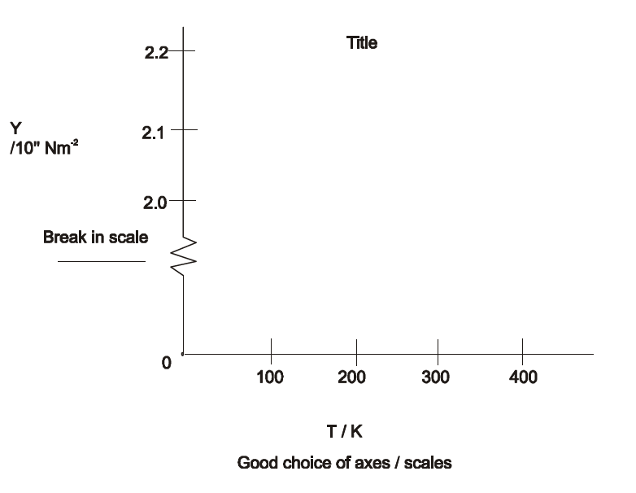

3. Choose the axes so that the points use the available space in a sensible way (show breaks in scale).

4. Title the graph.

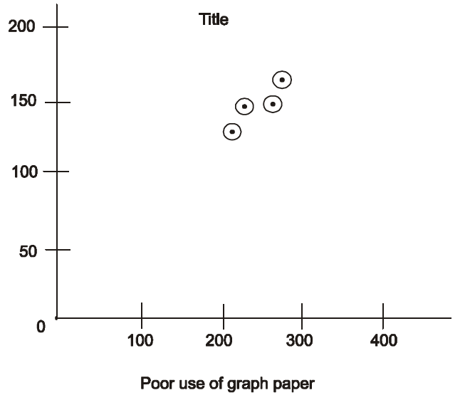

5. Plot points as dots surrounded by a small circle ‘’.

6. Draw the best straight line leaving the points spread evenly on both sides - do not make the graph go through the origin even if theoretically it should.

7. Take readings which are spread out evenly over the range of the quantity being measured.

8. Plot a graph as the experiment proceeds - check any points that seem widely off line. Plotting as the experiment proceeds also allows the distribution of points to be checked.

## Appendix 3. Uncertainties / Errors

Whenever a measurement is made, there is inevitably some uncertainty in its determined value. This uncertainty is often referred to as the ‘error’ on the measured value. Statistical methods have been developed for treating variations in experimental data. However, these will not be used in the present course. ‘Errors’ will be based on the limited accuracy of the laboratory instruments used in the experiments.

**The Calculus Method.**

The account of each experiment includes a section on error analysis. This suggests how the error on a calculated quantity should be worked out from the errors in the individually measured quantities on which the calculation depends e.g. in an experiment to determine the acceleration due to gravity ‘g’,



Here ‘g’ depends on the measured values of ‘L’ the length of the pendulum, and ‘T’ the period of oscillation.

There are a number of rules to calculating the errors this way. If a quantity A is calculated from the equation:



then the % error on A ( ΔA% ) is



It does not matter whether n, m or p are positive or negative, the % errors are always added.

Also n, m or p need not be whole numbers eg.  means .

Once the % error has been worked out on A, the actual error on A is calculated as:



The error on the individual items X, Y, Z etc. depend on the accuracy of the instrumentation eg. if X is a length ‘m’ measured with a metre stick whose accuracy is ±1 mm (10-3 m) then



Sometimes it is necessary to use a larger figure than the accuracy of the particular item of apparatus e.g. if a stop-clock with accuracy ±0.01 seconds is used to record an interval of time, the real error is the time taken to turn on and turn off the clock. This takes about 0.5 seconds, so ± 0.5 seconds would be a more reasonable measure of real accuracy.

In measuring the movement of a pointer along a scale two measurements are involved. If a metre stick is used each reading has an accuracy of ± 1 mm (10-3m). Hence the error on the difference in pointer positions is ± 2 mm (10-3m).

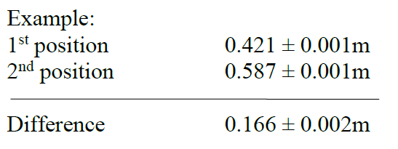

A similar approach is taken to calculating a change in temperature.

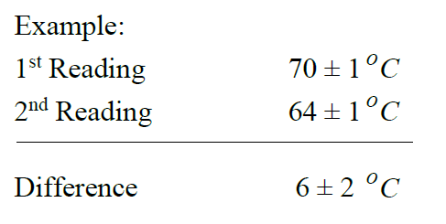

**The Error Range Method.**

The ‘Calculus’ method explained above is not suitable for complex equations.

e.g. 

The mean value of f (focal length) is calculated from a graph. To estimate the error choose typical values of d0 and di ; write these down including the error on each due to the experimental limitations i.e.



and



(where *d0*, *di* represent object and image distances respectively).

The **maximum value of *f*** within the errors Δ*d0* and Δ*di* is



assuming a real image i.e. *di* > 0

The **maximum value of *f*** is



again for a real image, *di* > 0.

Calculate Δ*f* , the error in *f*, as



**The Graphical Method.**

It is quite common to calculate a physical quantity from the slope of a straight line graph. This graph will have been plotted using experimentally measured values. A best fit will have been worked out with the points evenly distributed on both sides of this line. As explained in the section of the appendices on graphing, this ‘best fit’ should go through the ‘centroid’.

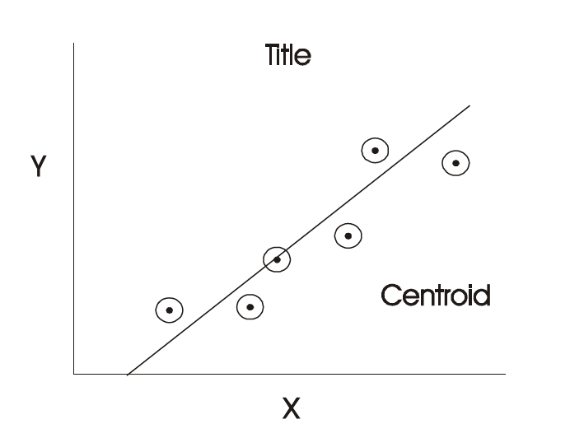

The equation of this graph is

*y = mx + c*

where ‘*m*’ is the slope and ‘*c*’ the Y intercept.

The graph can be used to estimate Δ*m* , the error in *m*.

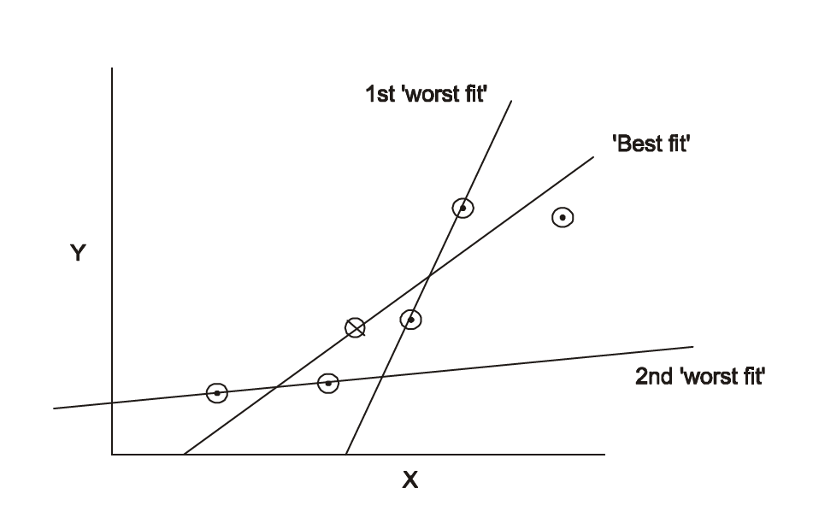

The ‘worst fit’ is the line through any two graph points which gives the greatest value for ‘m’ i.e which makes the largest angle with the X-axis. Assume m1 is the slope for the ‘best fit’ and m2 is the slope for the ‘worst fit’. An estimate for the error in *m* is



An alternative is to draw a second ‘worst fit’ line through two graph points which has the least slope i.e. a line which makes the smallest angle with the x-axis. If the slope of this line is m3, an estimate for the error in *m* is



## Appendix 4. Galvanometer

A galvanometer is an instrument that can detect and measure small current in an electrical circuit (see Fig. a). Essentially, galvanometer consists of a needle attached to a coil which is allowed to pivot freely within a magnetic field created by the poles of one or more permanent magnets (see Fig. b). When electricity is allowed to pass through the coil, the magnetic field (from north to south poles), generates a twisting force known as torque that rotates the coil, a response elucidated by the left hand rule. The deflection of the needle of the galvanometer is proportional to the current flowing through the coil.



Fig. AC5 galvanometer. (a) Appearance (b) Configuration of the galvanometer